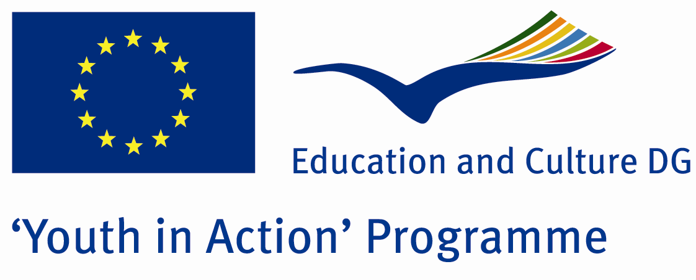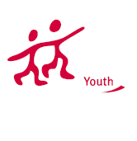

Languages History


ACTION 1.1 – Youth Exchange

09-16th January, 2012

Kilis, TURKEY

ACTION 1.1 - Youth Exchange
09-16th January, 2012

Kilis, TURKEY

Please contact directly to;
adventurerpeacepigeons@gmail.com

Project Summary;

Language is a tool for the deal among the people. Language is developing in each day, such as a living thing. There are 203 countries in the world and some of countries speak same language and some of countries speak more than 1 language. Therefore too many languages are spoken all over the world. Based on that we decided to do a project related to the birth of languages and history of the languages. We do this Project in Kilis. We chose this city because Kilis is very old city and Many civilizations lived here (Assyrian, Median, Parthian Empire, the Byzantine Empire, Seljuk Empire, Ottoman Empire, Britain, France, the Republic of Turkey) so that so many languages borned and spoken here. We will learn history of the languges, will visit historical and living places and all participants will teach their languges.

If you want to join this project, please contact us..

Project Title; The Birth of Languages

Date and Venue ; 09-16th January , 2012 Kilis, Turkey .

Target Group ; Municipalities, City Councils and Non-Governmental organizations,
youth groups,culture and art groups,e.t.c

Participants ; 5 people from each country (over 18 -25 ). Totally 8 countries.

Conditions ; Accommodation, board and programme costs will be financed through European Commission Youth in Action Programme (Action 4.3). Travel costs will be reimbursed in 70% (APEX Tarrifs). Organizations from all 27 EU member countries plus Liechtenstein , Norway and Iceland are eligible to take part.

Working language: English

Organizer; Adventurer Peace Pigeons

How to apply: If you are interested, please send your Part III forms to
by e-mail please (in word file). Scan Part3 format is enough for application.(Fulfilled Part III which you can find in the attachment, of course signed and stamped) ..

Next step 2;
Original send via regular post to this address please:
Ertan DERİN
Fevzi Çakmak Mahallesi Tuncer Sokak No:6 PENDİK/İSTANBUL/TÜRKİYE
e-mail : adventurerpeacepigeons@gmail.com
Mobile : 0090 542 393 93 90

If you have any questions you may contact with: adventurerpeacepigeons@gmail.com
Deadline: 15th May 2011

For Further information:
Contact Person
Ertan DERİN
Fevzi Çakmak Mahallesi Tuncer Sokak No:6 PENDİK/İSTANBUL/TÜRKİYE
e-mail : adventurerpeacepigeons@gmail.com
Mobile : 0090 542 393 93 90

